MINIMISING PHYSICAL RESTRAINT PROCEDURE

RATIONALE:

The Randwick School Board of Trustees is committed to providing a safe environment for all students, staff and visitors but also has a responsibility to minimize the use of physical restraint. Student and staff wellbeing is at the heart of this procedure. Inclusive practices and safe environments are of greatest importance for all students. There are times when student’s behaviour puts themselves or others in physical danger and these situations need to be managed safely and responsibly.

What is physical restraint?
Physical restraint is when a school staff member uses their own body to deliberately limit the movement of a student.

Physical restraint is not:
- Temporary physical contact, e.g. a hand on the arm, back or shoulders to remove a student from a situation to a safer place (unless the child is resisting)
- Holding a student with a disability, to move them to another location, or help them to get in a vehicle or use the stairs
- Harness restraint to keep a student and others safe in a moving vehicle, or when recommended by a physiotherapist or occupational therapist for safety or body positioning.

Physical restraint should only be used in emergency situations when:
- The student’s behaviour poses an imminent danger of physical injury to other students, staff, themselves or others
- Preventive and de-escalation techniques have been tried but have not reduced the potential for injury

Imminent danger exists when:
- A student is moving in with a weapon, or something that could be used as a weapon, and is clearly intent on using violence towards another person
- A student is physically attacking another person, or is about to
- A student is, for example, throwing furniture, computers, breaking glass close to others who would be injured if hit
- A student is putting themselves in danger, for example running onto a road, or trying to harm themselves.

Do not use restraint:
- For behaviour that is disrupting the classroom but not putting anyone at risk of injury
- For refusal to comply with an adult’s request
- In response to verbal threats
- To stop a student who is trying to leave the classroom or school without permission (unless there is imminent danger e.g. concern of them running towards a river, onto a road or into a dangerous property e.g. an area where large trucks and or machinery operate)
- As coercion, discipline or punishment
- For damaging property, unless this could cause injury or put people in imminent danger

Prior to using physical restraint:
Preventative techniques:

Students with Special Needs
- Individual plans may be put in place for students with special needs. These should be made in consultation with the family/carer.

Understand the student
- Get to know the student and identify potentially difficult times or situations that may be stressful or difficult for them.
- Identify the student’s personal signs of stress or unhappiness and intervene early.
- Monitor wider classroom/playground behaviour carefully for potential areas of conflict. Respect the student

Respect the student
- Demonstrate a supportive approach: “I’m here to help.”
- Be flexible in your responses: adapt what you’re doing to the demands of the situation.
- Be reasonable: a reasonable action, request or expectation deserves a reasonable response.
- Promote and accept compromise or negotiated solutions, while maintaining your authority.
- Take the student seriously and address issues quickly. Preserve the student’s dignity.

Preserve the student’s dignity
- Address private or sensitive issues in private.
- Avoid the use of inappropriate humour such as sarcasm or mocking.

De-escalation techniques:
Safety first – create space and time
- Remove the audience – ask other students to take their work and move away.
- Give the student physical space.
- Name the emotion in a calm even voice: “You look really angry”, “I can see that you are very frustrated”.
- Wait.

Communicate calmly
- Talk quietly, even when the student is loud.
- Try to remain calm and respectful.
- Monitor your own body language and allow the student the opportunity to move out of the situation with dignity.
- Focus on communicating respect and your desire to help.
- Keep verbal interactions respectful.
- When appropriate, give the student clear choices and/or directions to help them feel more secure and regain control.

Think ahead in case the situation escalates
- If escalation occurs, move further away.
- Make sure you have an exit plan.
- Constantly reassess the situation.
- Send for help if necessary.

What may escalate the behaviour
- Threatening the student.
- Arguing or interrupting.
- Contradicting what the student says – even if they are wrong.
- Challenging the student.
- Trying to shame the student or showing your disrespect for the student.
- Over verbalising.

Guidance if you have to use physical restraint:
What to do if prevention and de-escalation do not work
- Ideally, physical restraint should only be applied by staff trained in its safe use, and trained in emergency first aid such as CPR.
- There may be no one with training nearby. If, as an untrained adult, you feel you can use physical restraint safely – both for yourself and the student – use your judgement and intervene.
- If you do not have the skills or confidence to safely restrain a student, remove the other students from the scene and call for help.
- Call the police when a student cannot be managed safely and the imminent danger to students, staff or themselves remains after all alternatives have been explored.

Do not use these restraints
If you have to use physical restraint, avoid these restraint holds to minimise the likelihood of injuring a student:
- Physical restraint that inhibits the student’s breathing, speaking or main method of communication, for example physical restraint that inhibits a student’s ability to use sign language.
- Prone (face-down) physical restraint.
- Pressure points and pain holds.
- Tackling, sitting, lying or kneeling on a student.
- Pressure on the chest or neck.
- Hyperextension (bending back) of joints.
- Headlocks.
- Using force to take/drag a student, who is resisting, to another location.
- Restraint when moving a student from one place to another – trying to get them into a van or taxi, for example – when they are in an escalated state, as this may escalate them further.

Monitor wellbeing throughout when applying physical restraint
- The physical and psychological state of the student being restrained should be continuously monitored by the person performing the restraint and other people present.
- Apply physical restraint only for the minimum time necessary and stop as soon as the danger has passed.
- Monitor the physical and psychological wellbeing of both the student and the staff member who applied the restraint for the rest of the school day. Watch for shock, possible unnoticed injury and delayed effects.
- Contact parents or caregivers on the same day, as soon as possible after the incident, so they can monitor their child’s wellbeing at home.

Follow Up Procedures
At any time that a child needs to be physically restrained or removed from the class or the playground, the staff member must inform the principal or deputy principal. The attached Physical Restraint Incident Report and Reflection document must be completed within 24 hours of the incident. The principal will send the required documentation to the Ministry of Education.

Any child that needs to be physically restrained or removed will have their parents or caregivers contacted as soon as is possible and practical, no later than 24 hours after the event, and in writing if the parent cannot be contacted by phone or spoken to in person.

If restraint has been used a debriefing meeting will be held within two days of the incident. The meeting will include the staff involved, the principal or principal’s delegate, and another member of staff not involved in the physical restraint incident. The meeting may involve MOE Learning Support team, RTLB etc if they are involved with the student.

In debriefing, follow the Guidance for New Zealand Schools on Behaviour Management to Minimise Physical restraint booklet guidelines. Focus on the incident, the lead up to it, the different interventions used that were unsuccessful in de-escalating the behaviour, and what could have been done differently.

The BOT Chairperson will be notified within 24 hours when physical restraint has been used and all incidents will be minuted in the principal’s reports to the BOT.

Review Responsibility: BOT and Principal

Date Confirmed 14 December 2021

Principal …………………………………………

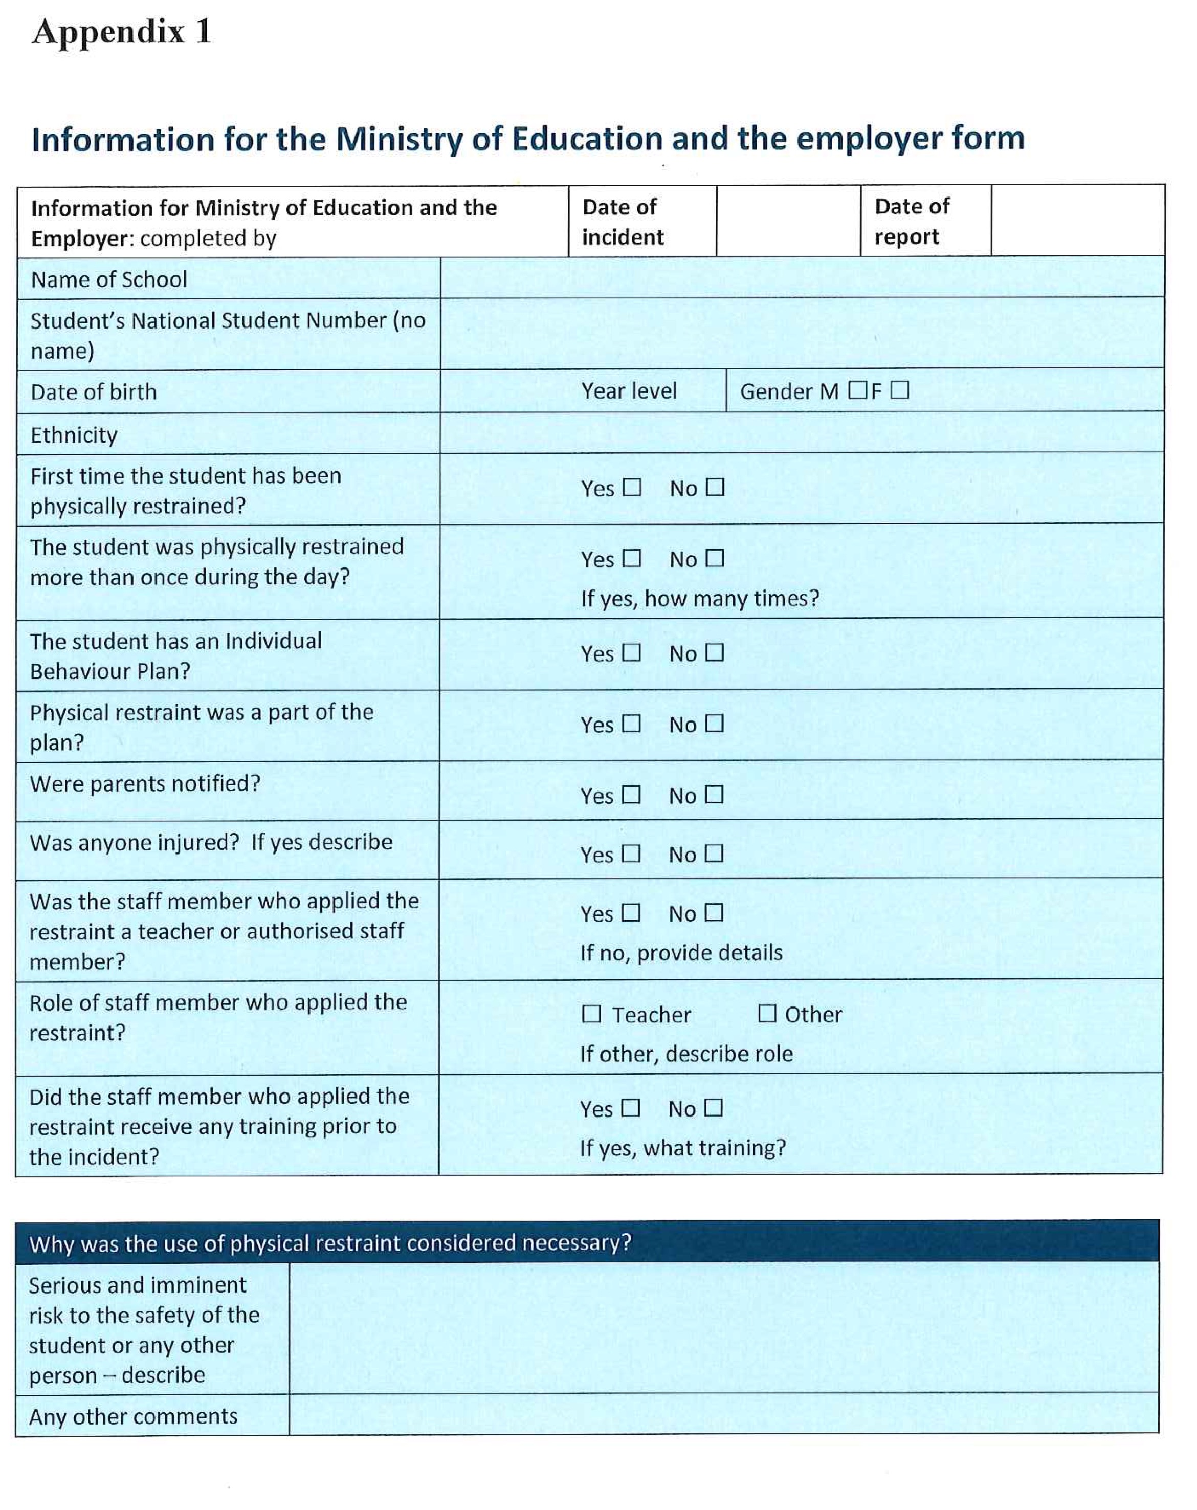

Incident of Physical Restraint Form
Information for the Ministry of Education and the Employer

Completed by
Date of Incident |  | Date of Report

School name & number
Student’s National Student Number (no name) |  | Date of Birth
Gender |  | Year Level

Ethnicity
First time the student has been physically restrained? | Yes / No (delete one) | The student was physically restrained more than once during the day? | Yes / No (delete one)  If yes, how many times?
The student has an Individual Behaviour Plan? | Yes / No (delete one) | Physical restraint was a part of the plan? | Yes / No (delete one)
Were parents notified? | Yes / No (delete one)
Was anyone injured? | Yes / No (delete one)  If yes, describe
Was the staff member who applied the restraint a teacher or authorised staff member? | Yes / No (delete one)  If no, provide details
Role of staff member who applied the restraint | Teacher / Other (delete one)  If Other, describe role:
Did the staff member who applied the restraint receive any training prior to the incident? | Yes / No (delete one)  If yes, what training?
Why was the use of physical restraint considered necessary?

Serious and imminent risk to the safety of the student or any other person – describe

Any other comments

Required Action
Complete the form above and email it to the Ministry of Education at mailto:physical.restraint@education.govt.nz Provide a copy to the employer (board of trustees, sponsor of a partnership school kura hourua, or manager of a private school)

Note: The information in this form may be the subject of requests made under the Privacy Act 1993 and the Official Information Act 1982.

Debriefing Reflection
Events leading to the incident
Describe what was happening before the behaviour started to escalate. What was the student doing? What do you think might have triggered the behaviour? How were other students reacting to the student?

Behaviour of the student
What did you notice about the student’s behaviour that alerted you that they were struggling to cope? Think about the way they looked, for example facial expressions, physical signs, language.

What did you try before the restraint?
Describe the alternative techniques and interventions tried to prevent the emergency, including a description of the de-escalation strategies you used. What was the response from the student?

The restraint method used
Describe the nature of the physical restraint. Include the type of hold and number of people required.

Monitoring
Describe how the student’s physical and emotional distress was monitored while they were restrained.

After the restraint ended
Describe the mood of the student following the restraint. What help and support were they offered?

If there’s a next time
What could be done differently in the future to prevent the need for restraint?

How about you?
How are you feeling and what support do you need?

